Jesus in a Box & Some Days Are Like This
August 31, 2017
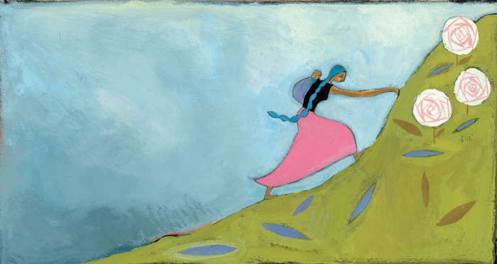
The Lord bless you, dear Heartdwellers. May your days be full of order and fruitful.

Pray for me. I’ve been having a hard time with distractions from multiple sources. And the Lord has been helping me—but I can also use prayers.

Well, I sat down to be with the Lord and hopefully get a message for you—and I had to apologize. "Lord, forgive me please—this has been a shotgun day, so full of distractions and I couldn’t get to prayer with You."

He answered me immediately, "I’m here. Some days are bound to be like this. You can do nothing more than bear with contradictions patiently—and in that, My will is fulfilled. But now we are going to get it back."

Hurray!

"Oh, thank You for Your mercy, Jesus."

Earlier in the evening, I had seen something about one of our nay-sayers, a lady with a Youtube channel assuring everyone I was deceived. But she wasn’t even right about our channel; she was talking about someone else’s channel. sigh.... I do grow weary with things like that. I ask my team not to send it to me—please, I don't want to see it! But sometimes they forget...

Well, the sting of that kinda lingered on and Jesus began to address it immediately.

He said, "What does it matter what people say about you— as long as I know who you are to Me?"

I answered Him, "Lord, didn’t it hurt You when people misunderstood or judged You?"

"It did, but for a different reason. Their God just visited them and it was a singular grace, but they missed their time of visitation and went on in their sins. That is why I was sad."

Well, it makes me sad because they are not able to discern Your voice, but the voice of another will surely seem right to them.

"This is true, and that is why people’s lives are riddled with confusion. Clare, by their fruits you will know them—yet by your fruits they still do not know you; they still do not know Me. What they know is a man-made version of Me. But they do not know Me experientially. That is why they cannot recognize My voice. Those who seek Me, will find Me. But many stop short and accept a counterfeit."

Why, Lord?

"They accept parts of Me which have been affirmed by their cultural and religious up-bringing. It's comfortable— but they stop there, thinking I fit into their box, and anything outside of that box couldn’t really be Me. People are bound by their peers and their cultures.

"It just isn’t safe to KNOW Jesus, I mean really KNOW Me.

"Some are jealous, some are afraid, some are lazy, but none of them is willing to dig until they get the real truth of Who I Am. They settle in a comfortable spot with their churches and families rather than be called a fanatic who is not happy until they have more of Me.

"There are others, who in their hearts hear My voice saying 'Come, come closer. There is more, don’t stop here! Continue to seek Me.' And they are willing to risk reputation, friends, work—anything to have more of Me. These are the ones that the world calls fools, but they are the ones I give My Heart to.

"I can do nothing for the others; their minds are already closed by cultural bias. I can act within their box of who they think I am, but that’s pretty limited and finite. More like hoarfrost on an iceberg. Little flakes on the tiny surface of a mountain-sized iceberg. Let them alone, Beloved, there is nothing you can do to convince them. Rather, you are a threat to their world and their faith."

Oh. that is so sad, Lord.

"It is. But they will go to Heaven, and then they will experience Me as I truly am. In the meantime, your messages from Me are causing more and more people to flock to My Heart and stay there forever. Be assured that those who ridicule and decry you will someday get the whole truth. Until then, remember them in your prayers and nourish the ones who want ALL there is of Me and nothing short of ALL that I am."

And here I would like to add, just as an aside, that I do not have all of Jesus!! Good grief, no! If I did, I'd probably die on the spot. Only what He has given me. But He can give you more and more of Himself when you seek to dwell in His heart. Don’t ever stop longing for more—there is no end to God!

Jesus, many people are talking about an event in September.

The Lord replied, "Men are still trying to calculate and second guess Me." He took a deep sigh. "...while they continue to neglect the good in front of them that they desperately need to do while there is time for them."

Ummm... Speaking of time…?

He smiled, “I knew that would spark that question. Your answer is ‘holding steady.’ Do not get under condemnation, by the way, when you don’t pray as you should. Just make a firm resolution to return to praying as you should.”

Yeah - today I just didn't pray the way I needed to.

"But what I wanted to ask You, Lord—is the greater danger past?"

“No. It is still very, very close. Don’t stop praying. My Father hears your prayers, Clare, and the cries of all the Heartdwellers for mercy on the world. This is why many of you are experiencing chaotic days, greater pain in your bodies, more opposition and lack. These are ways I am distributing the load in My Body. Everyone has something difficult to deal with and carry—their Simon’s Cross. And it is accomplishing much good. But you cannot afford to stop, it is still too close to call.

"Dear Brides, I know your hopes and dreams. I know your disappointments and choices to persevere even when things do not go your way. And I am highly honored when you choose to take this cross on your shoulders and carry it. It is your willingness to suffer with Me, to carry a portion of My Cross for the world that honors Me.

"Everyone loves abundance and rewards, and no one wants to be in pain and suffering—except the ones who Love Me more than themselves. And they are the ones that comfort My heart, that dry My tears, that make Me smile. Yes, you do all these things, My Brides; you are My consolation on this bitter Earth. You bring Me hope and joy. You are My Beloved ones.

"We are still climbing that long, long hill, even to Calvary, until I return to receive My Kingdom on Earth. We will be climbing together and preparing the world together for My return. So, do not grow weary.

"Oh I know, I say it so many times, ‘do not grow weary.’ I know some of you even feel a bit scornful that I am still saying that. Please, do not sin against Me that way. Please accept these words as they are meant, sincerely from My Heart, to encourage you to keep going even in the pains of this struggle. Even in the midst of chides from the scornful, 'Where is your God? He hasn’t come yet! Maybe He’s asleep?'

"If you must, ask Me for more faith. And some day you will see the very great reward I have prepared for you, because you were steadfast even in fatigue, scorn and contempt. Even when people called you deceived. Oh yes, I know many call you deceived. Pray for them; their cup will be very bitter indeed when they are left behind.

"For most of you the Rapture will happen in your lifetime. There are others I am calling home; they have given their all and I am anxious to reward them. Stand strong, My Brides, stand strong. Be the light and the salt of this Earth."

That was the end of His message, and what a precious message it was. He is so kind and long-suffering with me, and any time I'm tempted to get angry with someone, or get short-tempered, I remember how patient He is for me—and it brings really strong conviction.

Dear ones, our days here have been very difficult and that’s why you haven’t heard from me as much as you should. I have observed that I go through times of prolific messages, and dry times, because the Lord is keeping my head above water. I am not fit for this job, and as I’ve told you many times before, that’s why He chose me. That way, He would get all the credit.

There are those around us in Taos who are experiencing very difficult times. Today, we broke the piggy bank for a young mother who was giving birth, and she got into a serious situation where the life of the child was compromised. She had to be transported by helicopter to Albuquerque. And the electric company called me and asked for help, because her $300 electric bill could not be paid by anyone else in town and was going to be turned off—on top of all her other crisis and race to save the baby.

So we, thanks be to God, were able to help her, but just barely. I say this because I want you to know when we see pain like this and the starvation in Sudan, as well as the critical need for food in Nicaragua, we sacrifice everything we have to help.

So, your donations do not end here. We do our best to help single mothers in crisis and support our local pregnancy center, which by the way, has a wonderful reputation for keeping young girls from abortion clinics. Recently, they purchased a van to travel to outlying communities and do ultrasounds, exams and pregnancy tests, as well as setting the girls up with everything they need for their baby's birth and getting them the assistance mothers need.

So, thank you for your faithfulness. The Lord has stored up riches for you in Heaven—for where your heart is, there also will be your treasure. And our hearts can’t be in any greater place than to take care of one another, and especially those who have no one else to turn to.

